**OUTPUT**

Case 1: Dimensions are integer

l = 12, b = 3

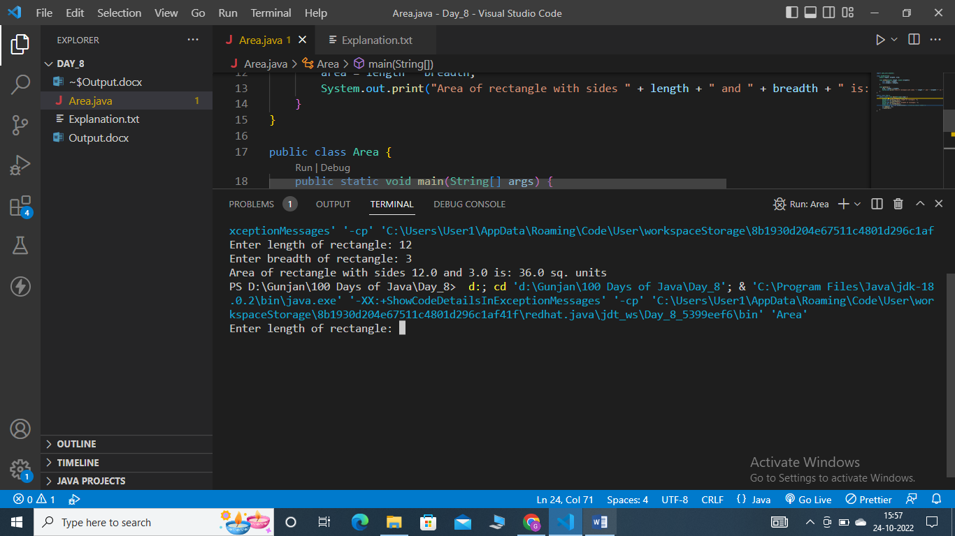

Case 2: Dimensions are decimals

l = 2.6, b = 3.2

